

SOFTWARE ENGINEERING GROUP PROJECT

CPSC-60500-005

By

Cesar Mendoza

Surya Reddy Kalva

Pallavi Karengala

Johnny Rebollar  
 Vimochana Veronica Ruth Dubba

**Group Project Name: Wandering in the Woods Game**

**(**Augmented Reality Room Designer)

Department Of Computer and Mathematical Science

Concentration in Software Engineering

Table Of Contents

1. Introduction
2. User manual Documentation
3. Conclusion
4. References

# Introduction

This document describes the software design of the Augmented Reality (AR) Room Designer. In this project we will be making a small game/simulation that has 3 modes, one for K-2, 3-5, and 6-8, K-2 Is just automated while the subsequent modes are more user interactive. For this project we decided to use C# to take advantage of .NET's use of WinForms to quickly make a game without having to dwell too deep in other programming languages. We view this document as being useful for instructors who wish to explore the ideas of the AR Room Designer. We invite critiques and suggestions for improvement of the document and model.

Importance

**Game Description:**

* Wandering in the Woods Game: People are “lost in the woods” where the woods are represented by a rectangular grid.
* The woods are dense, and the people can’t see or hear each other until they are in the same cell of the grid.

GRADES K-2

* In grades K-2, the grids are always square, there are always two people, and they start out in diagonally opposite corners of the grid.

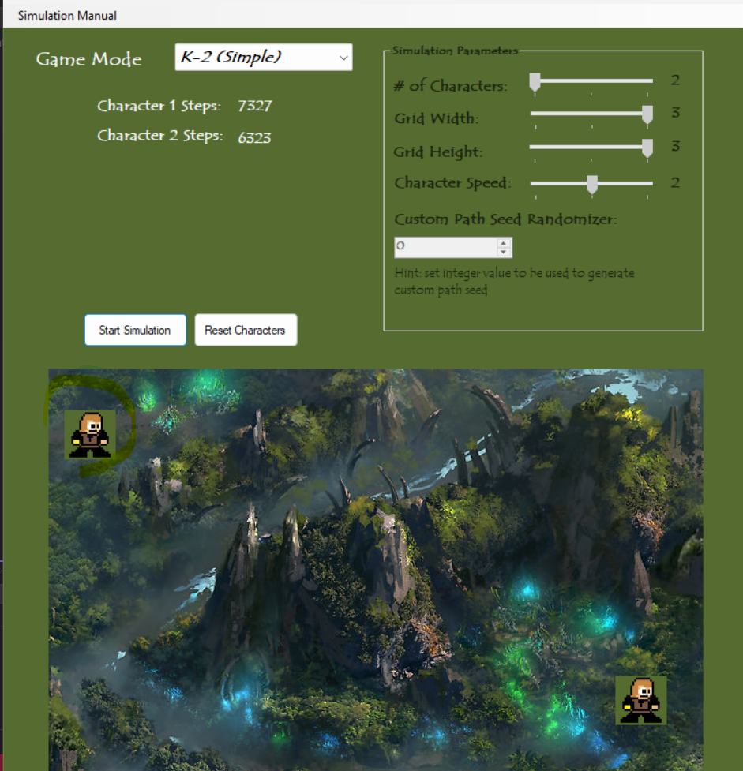

* They wander about randomly, and each move is counted, with a counter for each person. Music plays as cartoon characters wander in the woods. The counter i.e character steps are increasing as they move.

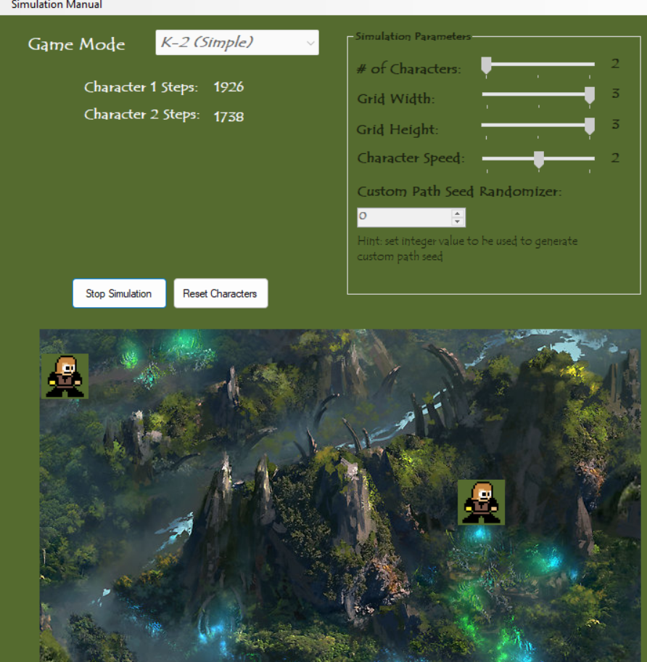

* When the people bump into each other they become red , there is a happy graphics display, and statistics from the wandering are displayed and announced audibly. Then the game is reset, and students can start it up again.

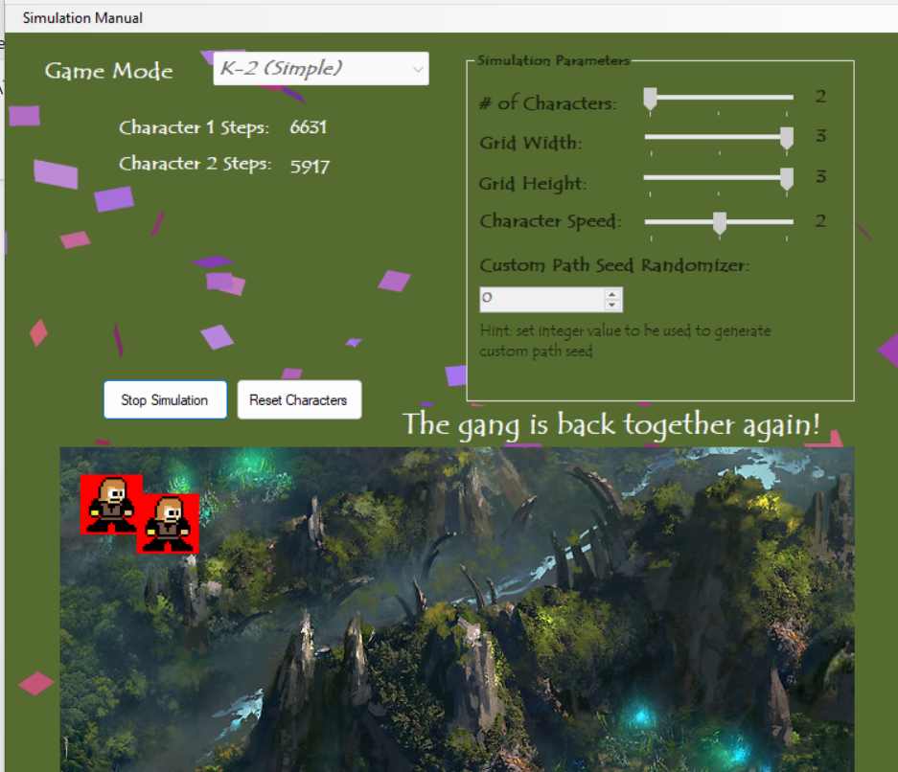

GRADES 3-5

* For grades 3-5, students can set up the size of a grid, which can be rectangular (instead of just square). Here we have the grid adjustability, the following is grid width and height with I reading.

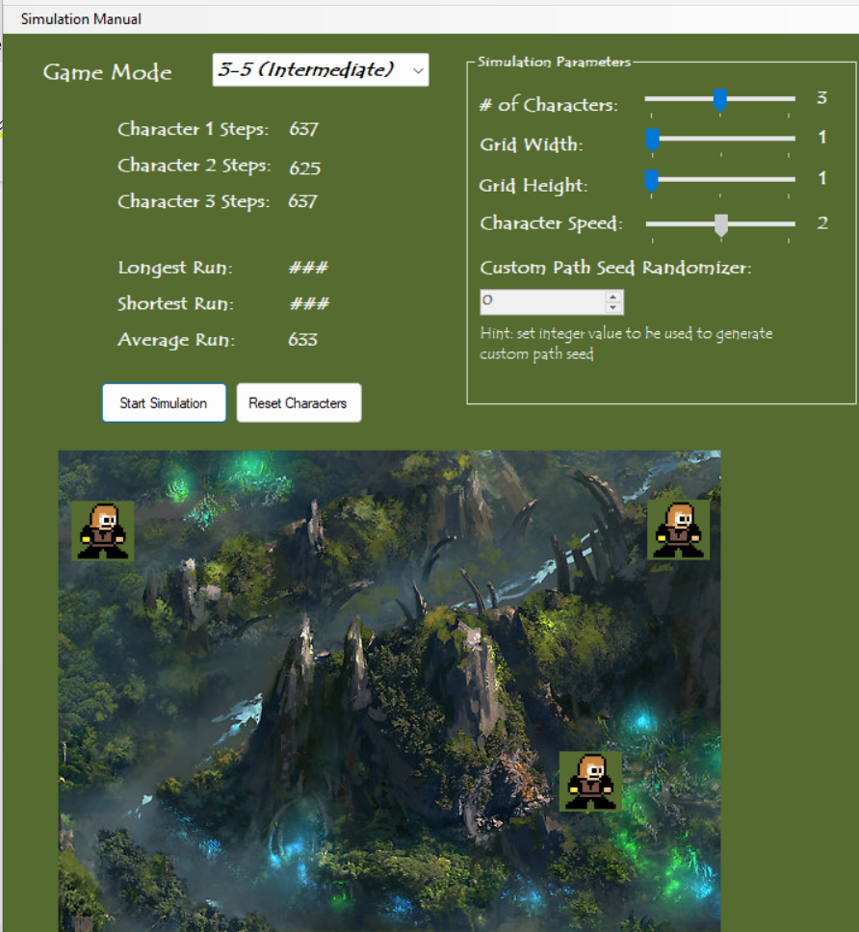

The following the is the screenshot after changing the grid readings.

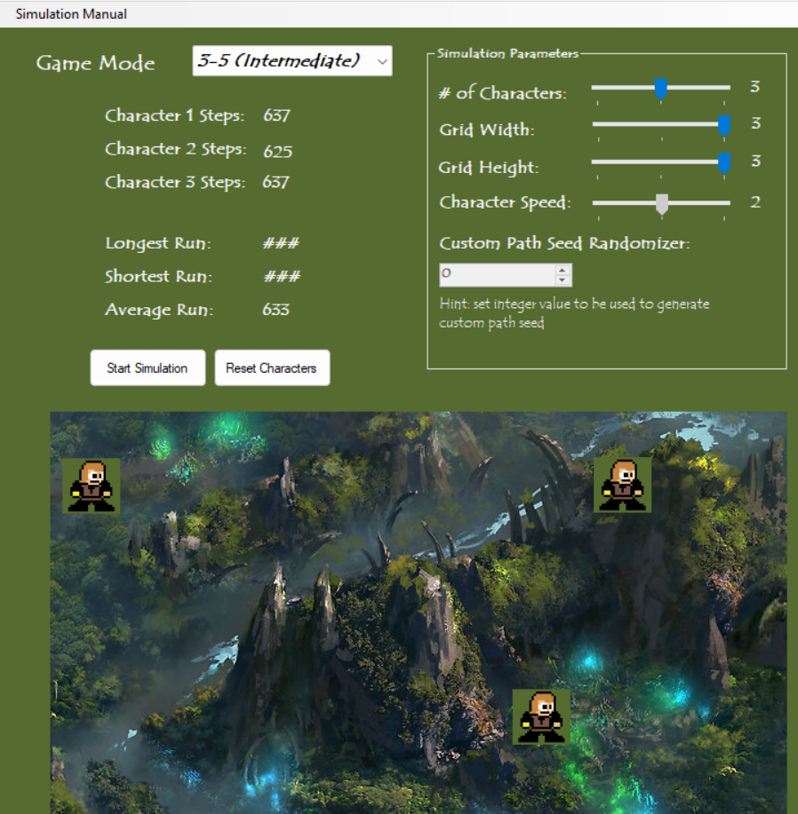

* Here as shown above we have 4 players, and students can place them wherever on their grid. Once the game is started, it can be played and replayed multiple times. Statistics (such as longest run without meeting, shortest run, and average run) are displayed.

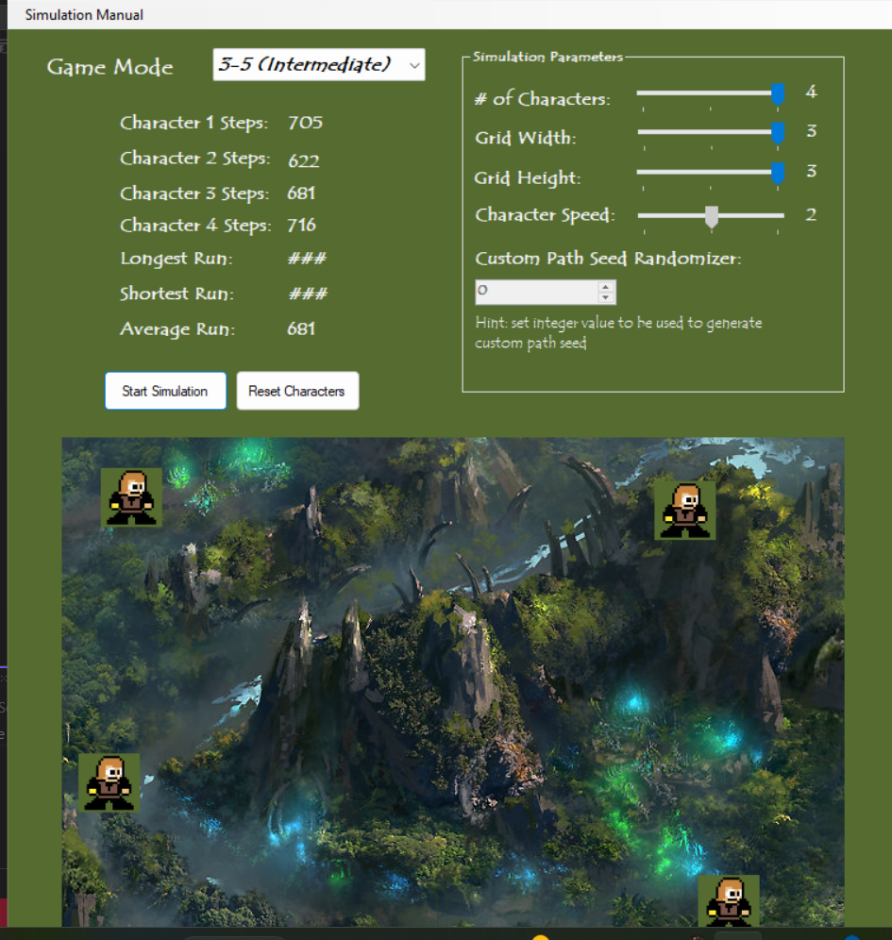

* If the game is played with 3 or 4 players, if two find each other, they will be moving together until they find the third player and once any two come closer they turn into purple.

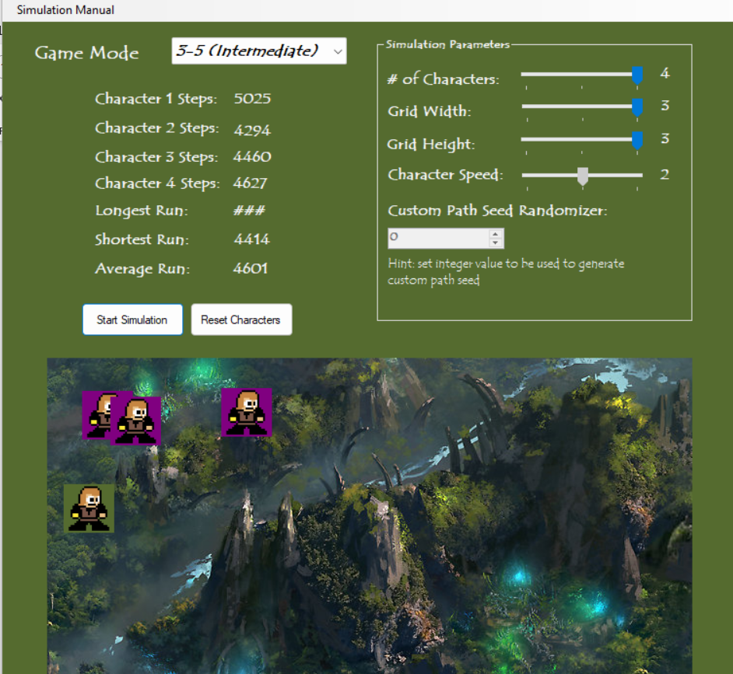

* In the same way, if the third player is found (assuming we have 4 players), the three players will move together until the fourth player is found.
* Once all are fond they turn out into red with the related audio .

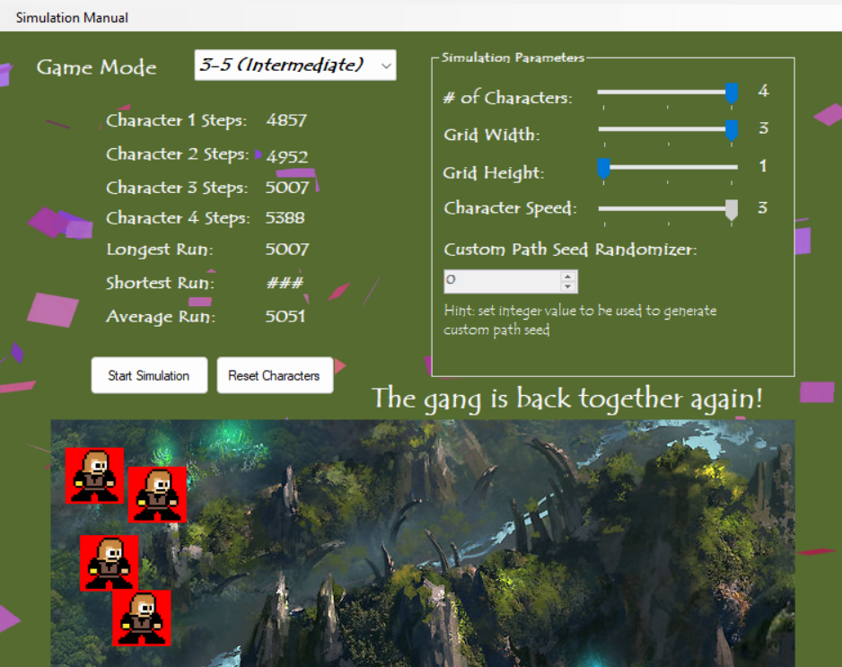

GRADES 6-8

* In grades 6-8, students have all the control of the 3-5 game, but 6-8 students will be challenged to run experiments to determine how the average run varies with the size and shape of the grids. They will also be able to explore different protocols for wandering, and to decide which is the best way to wander if you want to shorten the time it takes to meet up.

The following is the one with grid width 1 and grid height 1 with speed 3.We can look the difference of steps made.

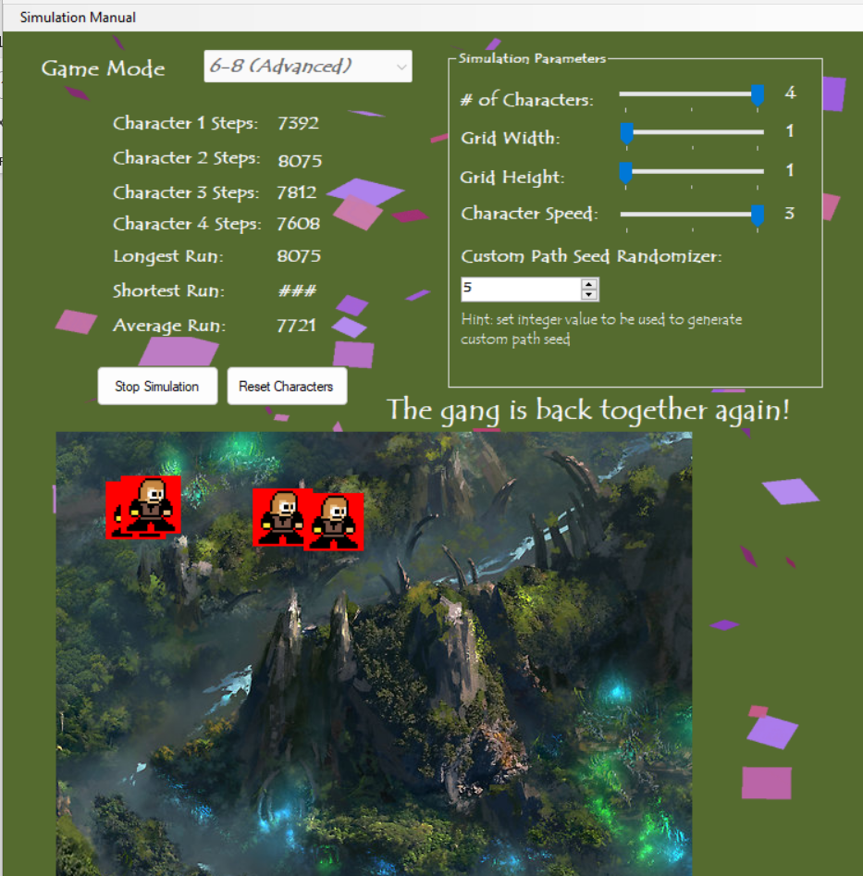

The following is the one with grid width 3 and grid height 3 with speed 2.We can look the difference of steps made.

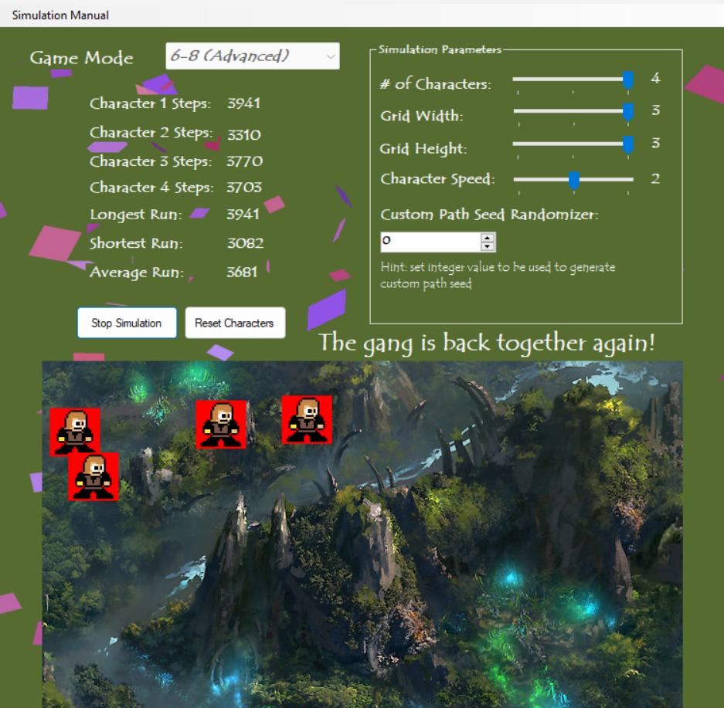

As such, there is difference in the counter of steps due to difference in width, height and speed and also number of characters.